11.4: a) The force is applied at the center of mass, so the applied force must have the same magnitude as the weight of the door, or 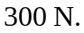 In this case, the hinge exerts no force.
b) With respect to the hinge, the moment arm of the applied force is twice the distance to the center of mass, so the force has half the magnitude of the weight, or 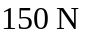. The hinge supplies an upward force of 